名字: __________________________ 號碼: ______ 日期:___________________
數學功課 (Math): _________________________
Lesson 19: 怎麼走？ (How Can I Get There?)
Lessons 19 Quiz – Thursday, February 17
Please review the following characters with your child. There are two lists: characters for writing AND characters for reading.

WRITING: They will be assessed on writing the…
- high frequency characters (HFC) 2. HFC’s stroke orders 3. HFC phrases

STROKE ORDER:
The numbers on the following characters indicate the sequence and the start of each stroke. Students start each stroke at a number and do NOT lift their pencil until they reach the arrowhead).
Please open the digital version of this document (included in the weekly newsletter or msaprilwu.weebly.com under “Curriculum”) to click on each individual character for an audio reading, stroke order animation (very important!), definitions, etc.

READING/VOCABULARY:
1. Fill-in-the-blank questions. They do NOT need to know how to write these characters.

High Frequency Characters and Phrases
**Characters in parentheses are extra credit**

請  please | 問  to ask | 怎  how | 東  east
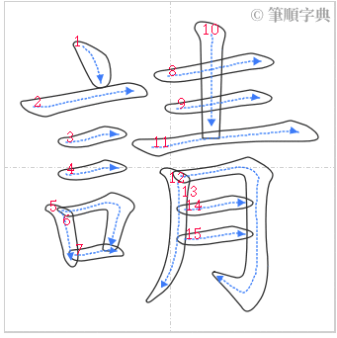 | 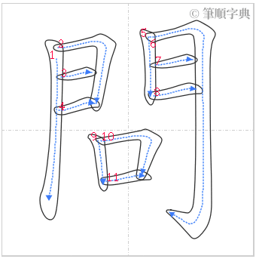 | 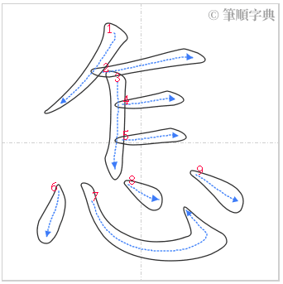 | 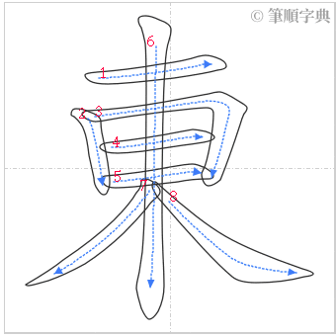
請問  excuse me/can you tell me… | 請問  excuse me/can you tell me… | 怎麼(走)  which way (should I take?); How can I get there? | 東(西南北)  north, south, east, west

Reading/Vocabulary
怎麼 | 走 | 一直 | 往 | 到 | 左轉 | 右轉 | 就 | 路口
how | to walk | straight | head to | to arrive/reach | to turn left | to turn right | then | intersection

