名字: __________________________ 號碼: ______ 日期:___________________
數學功課 (Math): _________________________

Lesson 23: 什麼動物鼻子長? (Which Animal Has a Long Nose?)
Character Quiz – Friday, May 6

Please review the following characters with your child. There are two lists: characters for writing AND characters for reading.

WRITING: They will be assessed on writing the…
- high frequency characters (HFC) 2. HFC’s stroke orders 3. HFC phrases

STROKE ORDER:
The numbers on the following characters indicate the sequence and the start of each stroke. Students start each stroke at a number and do NOT lift their pencil until they reach the arrowhead).
Please open the digital version of this document (included in the weekly newsletter or msaprilwu.weebly.com under “Curriculum”) to click on each individual character for an audio reading, stroke order animation (very important!), definitions, etc.

READING/VOCABULARY:
1. Fill-in-the-blank questions. They do NOT need to know how to write these characters.

High Frequency Characters and Phrases
**Characters in parentheses are extra credit**

動  to move | 物  object, thing | 尾  tail, remainder | 長  long, length
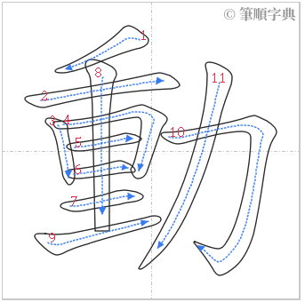 | 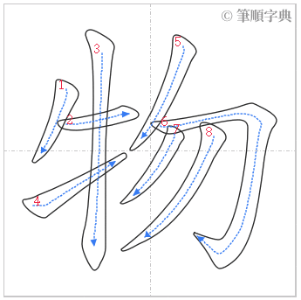 | 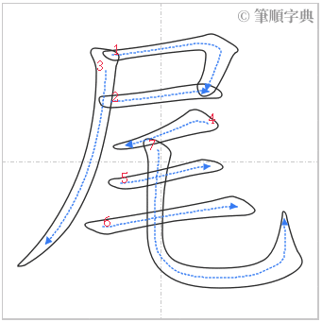 | 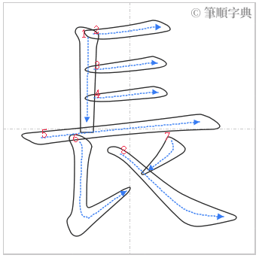
動物  animals | 人物  characters (in a book, movie, etc.) | 尾巴  tail | 長(脖)子  long neck

Reading/Vocabulary
大象 | 兔子 | 脖子 | 長頸鹿 | 身體 | 蛇 | 猴子
elephant | rabbit | neck | giraffe | body | snake | monkey

