Lesson 20: 多少錢？ (How Much?)

Please review the following characters with your child for the upcoming character quiz. There are two lists: characters for writing AND characters for reading.

WRITING: They will be assessed on writing the…
- high frequency characters (HFC) 2. HFC’s stroke orders 3. HFC phrases
STROKE ORDER:
The numbers on the following characters indicate the sequence and the start of each stroke. Students start each stroke at a number and end the stroke at the arrowhead. (They do NOT lift their pencil until they reach the arrowhead).
Please open the digital version of this document (included in the weekly newsletter or msaprilwu.weebly.com under “Curriculum”) to click on each individual character for an audio reading, stroke order animation (very important! ), definitions, etc.

READING/VOCABULARY:
- Be able to choose the correct phrase to fill-in-the-blank.
- They do NOT need to know how to write these characters.

High Frequency Characters and Phrases
**Characters in parentheses are extra credit**

少  few, little, less | 錢  money | 要  to want, need to | 買  to buy
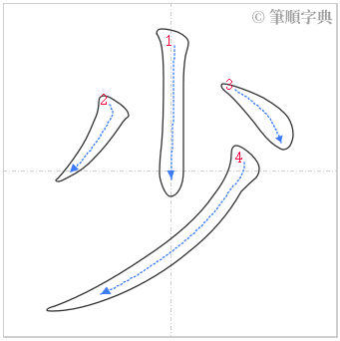 | 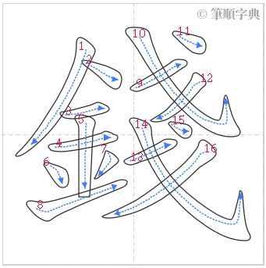 | 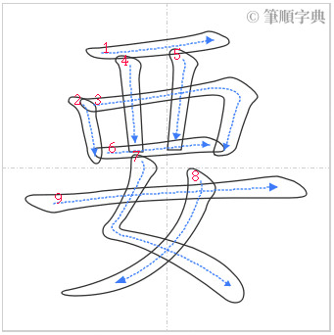 | 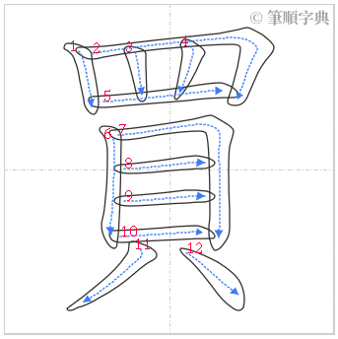
多少  how many, how much | 多少錢  How much? | 要不要  Do you want… | 買賣  to buy and sell

本 | 塊 | 太 | 貴 | 可以 | 給 | 吧 | 不客氣
measure word for books | measure word for various objects | too | expensive | ok, all right | to give | grammatical word indicating a suggestion or a rhetorical question | You’re welcome
Reading/Vocabulary

