名字: __________________________ 號碼: ______ 日期:___________________
數學功課 (Math): _________________________
中文功課 (Mandarin): Lesson 16: 我喜歡運動 (I Like to Exercise)
Character Quiz – Friday, November 19
Please review the following characters with your child. There are two lists: characters for writing AND characters for reading.

WRITING: They will be assessed on writing the…
- high frequency characters (HFC) 2. HFC’s stroke orders 3. HFC phrases

STROKE ORDER:
The numbers on the following characters indicate the sequence and the start of each stroke. Students start each stroke at a number and end the stroke at the arrowhead. (They do NOT lift their pencil until they reach the arrowhead).
Please open the digital version of this document (included in the weekly newsletter or msaprilwu.weebly.com under “Curriculum”) to click on each individual character for an audio reading, stroke order animation (very important!), definitions, etc.

READING/VOCABULARY:
1. Fill-in-the-blank questions. They do NOT need to know how to write these characters.
High Frequency Characters and Phrases (Writing)
**Characters in parentheses are extra credit**
最  most | 打  to play (hit) | 球  ball | 冰  ice | 會  can/be able to
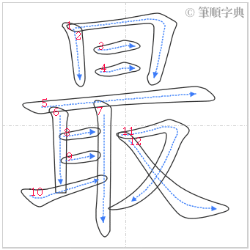 | 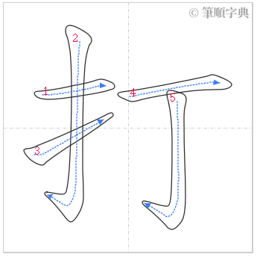 | 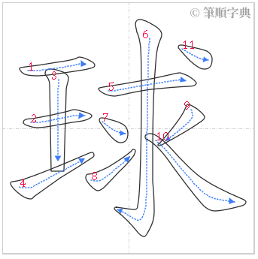 | 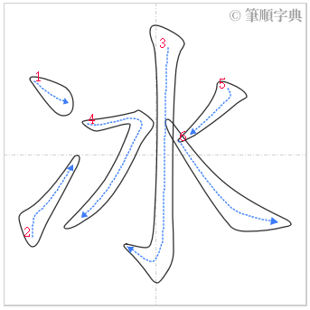 | 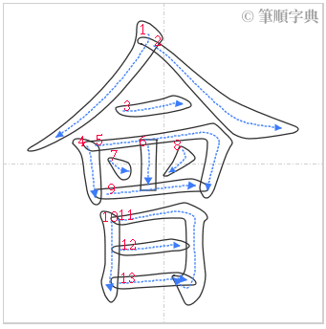
最(棒)  the best | 打球  play ball | (棒)球  baseball | 冰球  ice hockey | 不會  will not

Reading/Vocabulary
運動 | 游泳 | 自行車 | 籃球 | 足球 | 踢
exercise, sport | swimming, to swim | bicycle | basketball | soccer | to kick
乒乓球 | 網球 | 跑步 | 棒球 | 騎車
table tennis (ping pong) | tennis | to run, jog | baseball | cycling, to ride a bike

